
Wipro PARI Group
Standard Functions

Overview
Usage information of Download Enable and Disable Add In.
Item Name: | Download Enable and Disable Add In
Classification: | Tools
Item Code: | <<Item Code>>
Reviewed By: | Sainath Basutkar | Reference Project Code | NA

Version History
Version No. | Date | Revision By | Revision Note(s)
1.0 | 06-04-2026 | Sushant Y. Patil | Initial release
Created by | Sushant Y. Patil
Approved by | Sainath Basutkar

Description/Functionality
Overview:
Item | Description/Details
Hardware/Software Requirements | - Tia Portal V18, V19, V20  - Tia Openness V18, V19, V20
Memory requirements | 40 MB
Restrictions and Precautions | Preinstalled of Tia Portal V18, V19, V20 with openness.

Adding users to the "Siemens TIA Openness" user group
Procedure: -
- Search “Computer Management” in start menu.
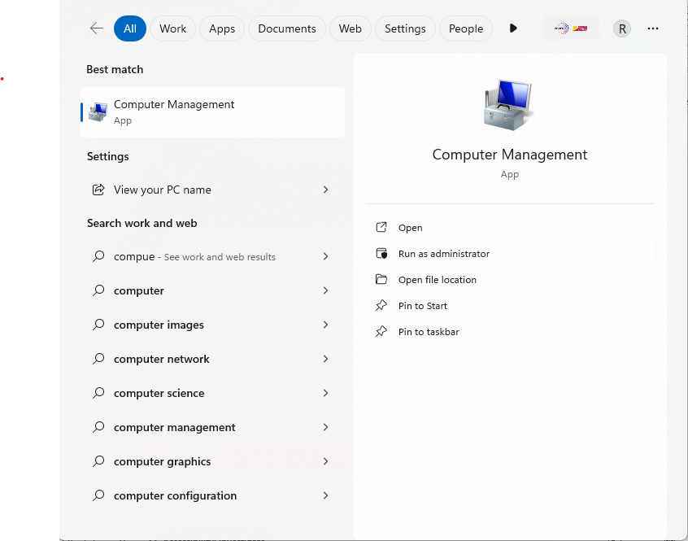
- Right click “Computer Management” and “Run as Administrator”.
- Select "Local Users and Groups” > “Groups", to display all created user groups.
- Select the "Siemens TIA Openness" entry from the list of user groups in the right panel.
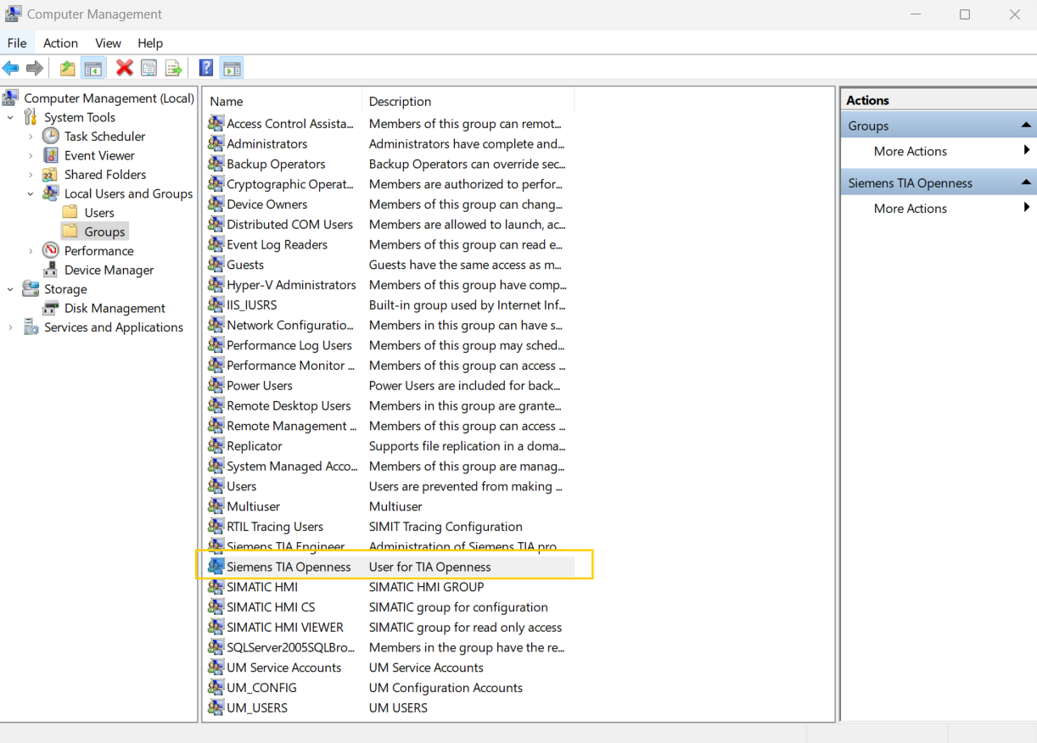

- Select the "Action” > “Add to Group..." menu command

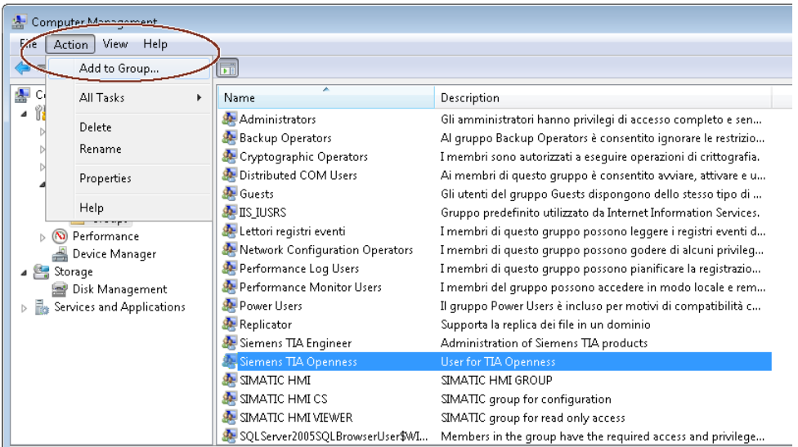

- The attributes dialog of the user group opens:
- Click "Add".
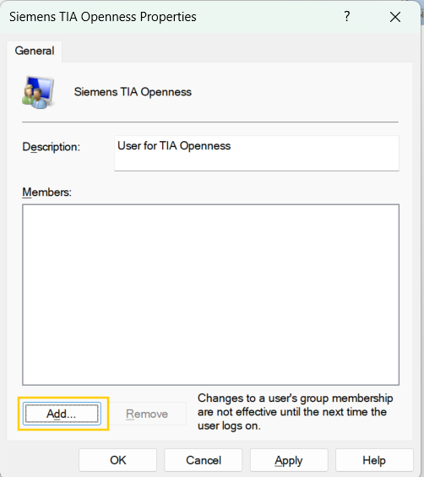
- The selection dialog that opens displays the users that can be selected
- Click “Locations”.

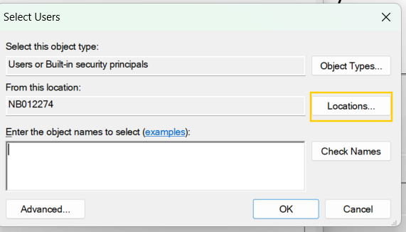

- “Cancel” Username and password window.
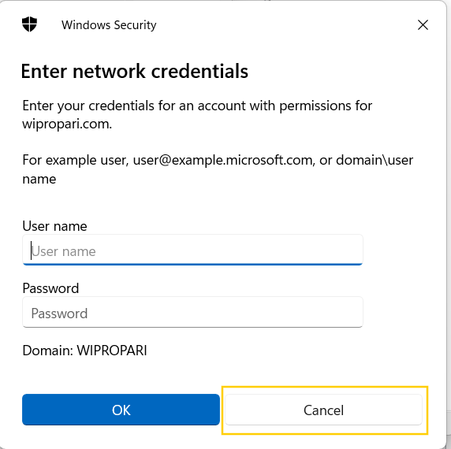

- Select PC Name and click on “OK”.
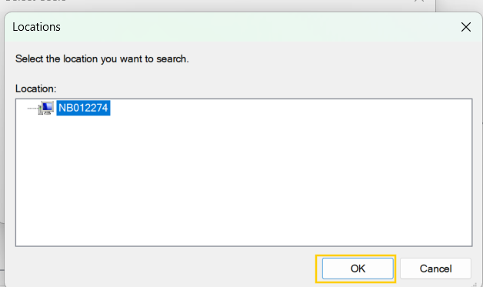

- Click “Advanced”-> “Find Now”. Select User from search results.
Click “OK”.
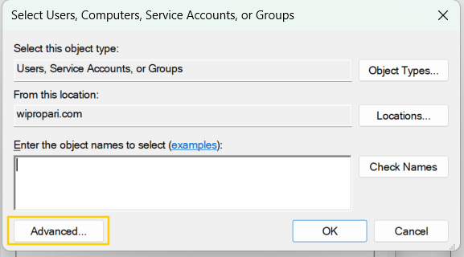
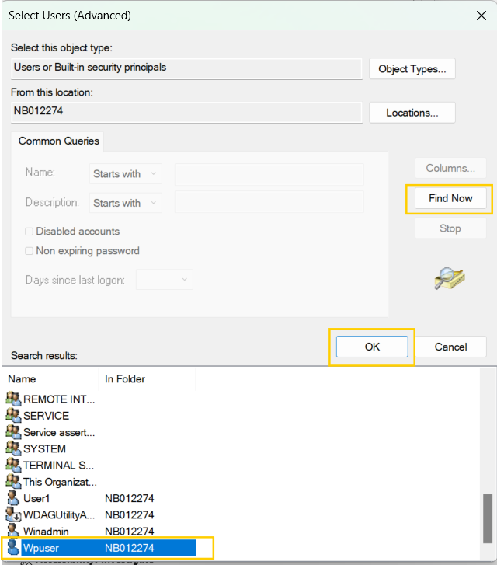
3
2
1

- Click “Check Names”, then Click “OK”.
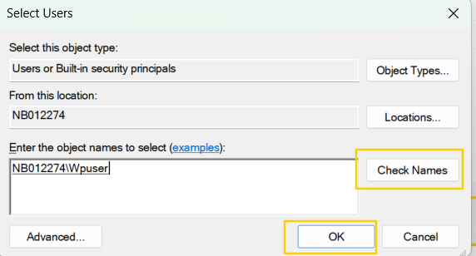
- See user added in group. Click on “Apply” then “Ok”.
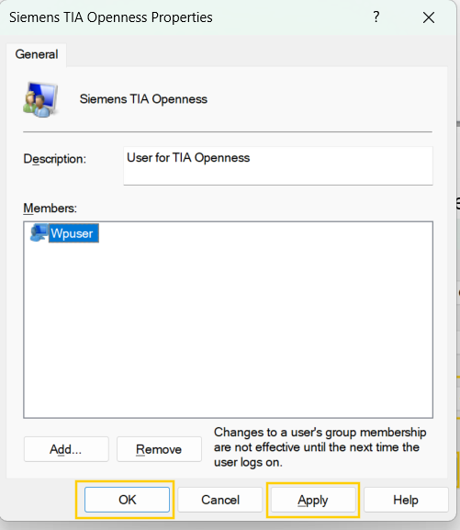

Usage Steps :
- Take the “DownlaodAccessAddin” folder from the authorized person and paste/add it into the C drive.
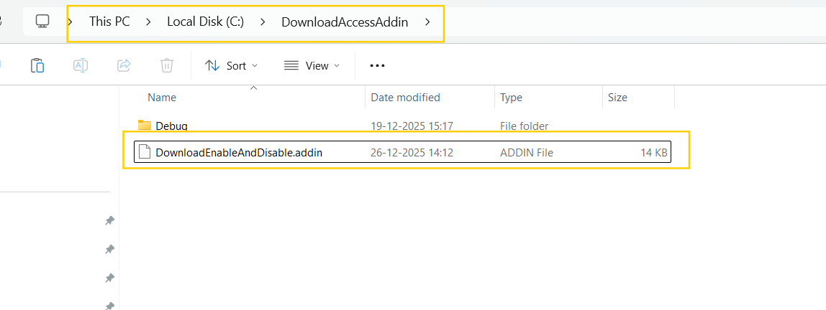
- Cut Paste the DownloadEnableAndDisable.addin file on the below path.
“C:\Program Files\Siemens\Automation\Portal V18\AddIns”
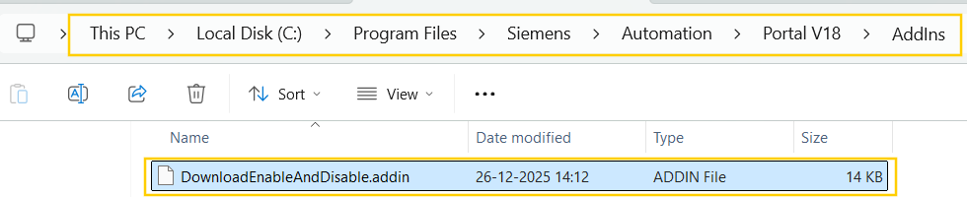
- Activate Add In.
Open the Project Select “Add-Ins” > “Activete” from the drop-down menu.
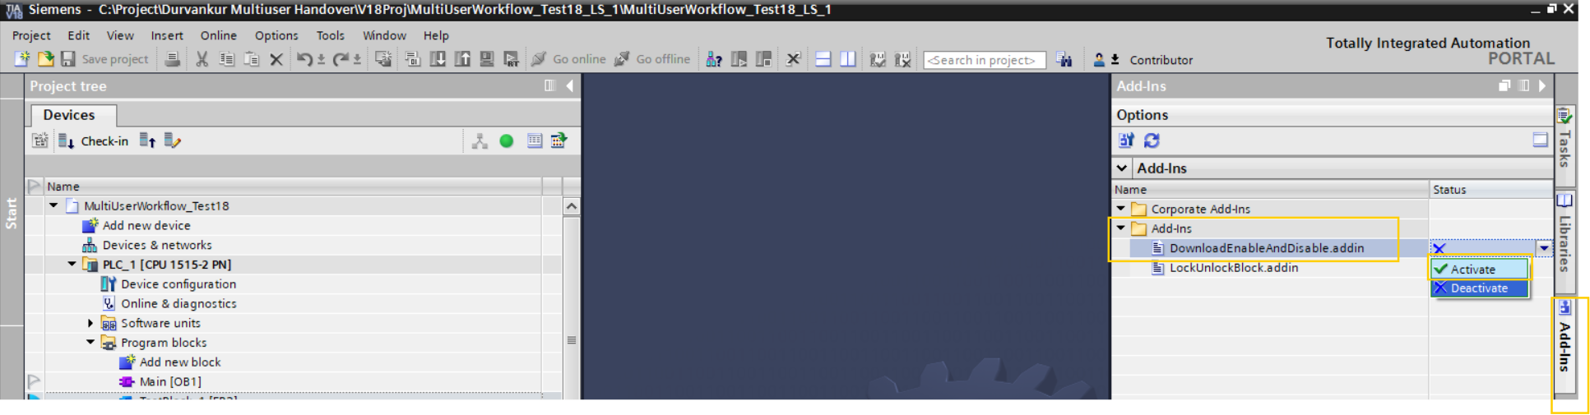

Click On “Yes” option.
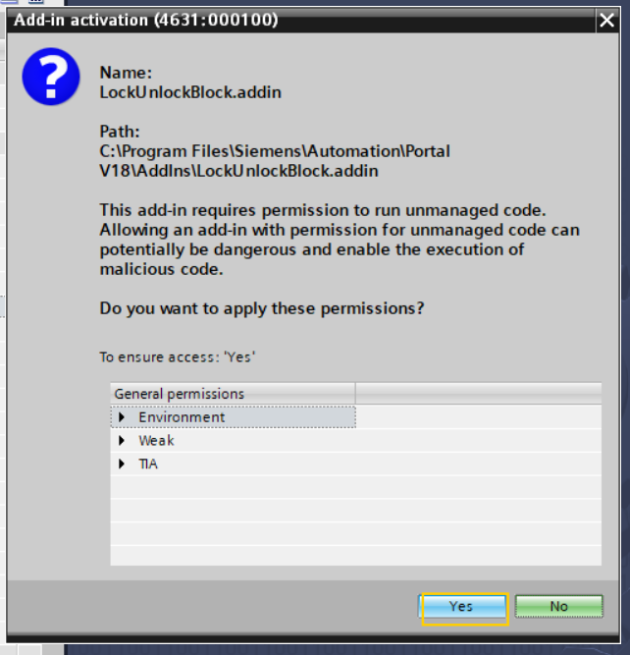

If download rights are not granted to the Contributor user, the below error pop-up is displayed when user tries to download.
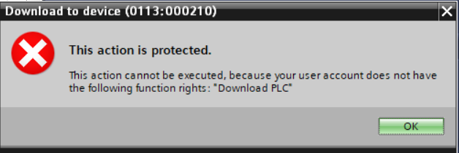

- Download Enable.
Right click on the Program blocks. click on “Download Enable And Disable” > “Download Enable”.
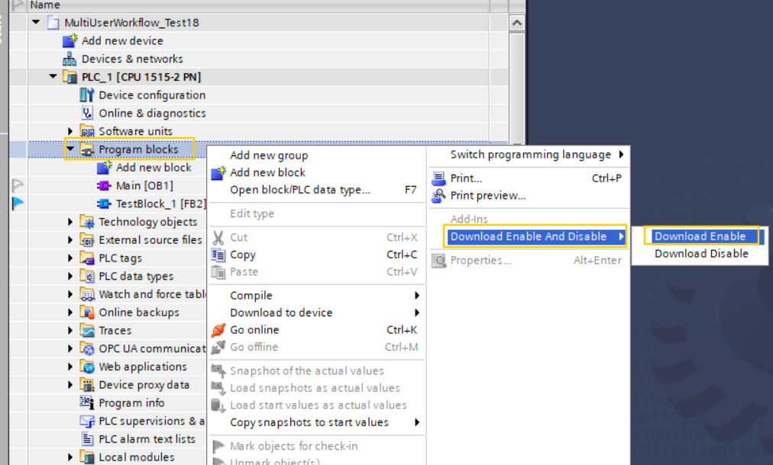

Select the Project server from the drop-down menu.
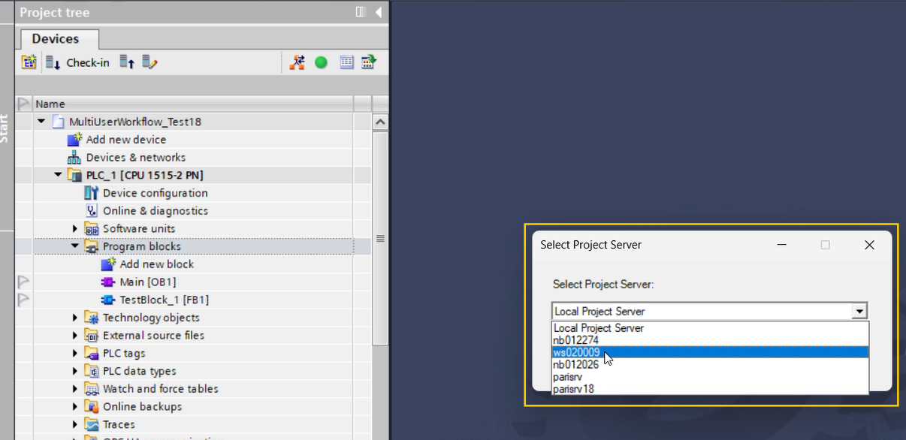

After adding the download rights, a pop-up message is displayed: “Download Access Granted. Please relogin.” After relogin, the user can download the program.
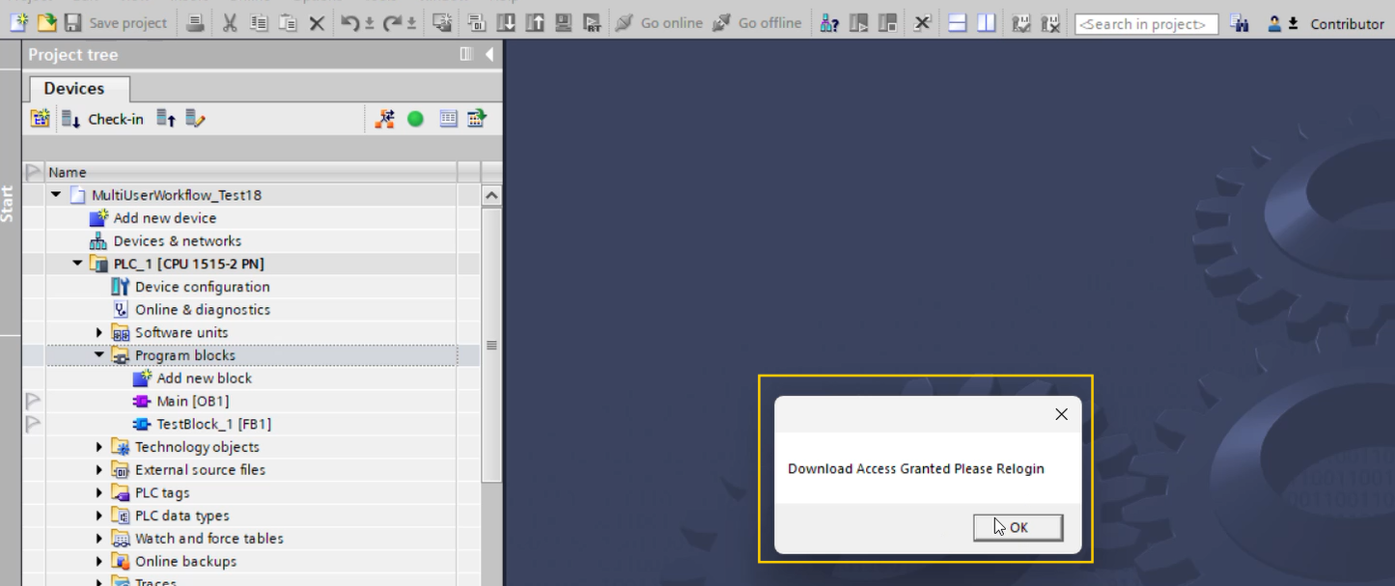

For relogin follow the below steps :

Select the “Change user” from the user section.
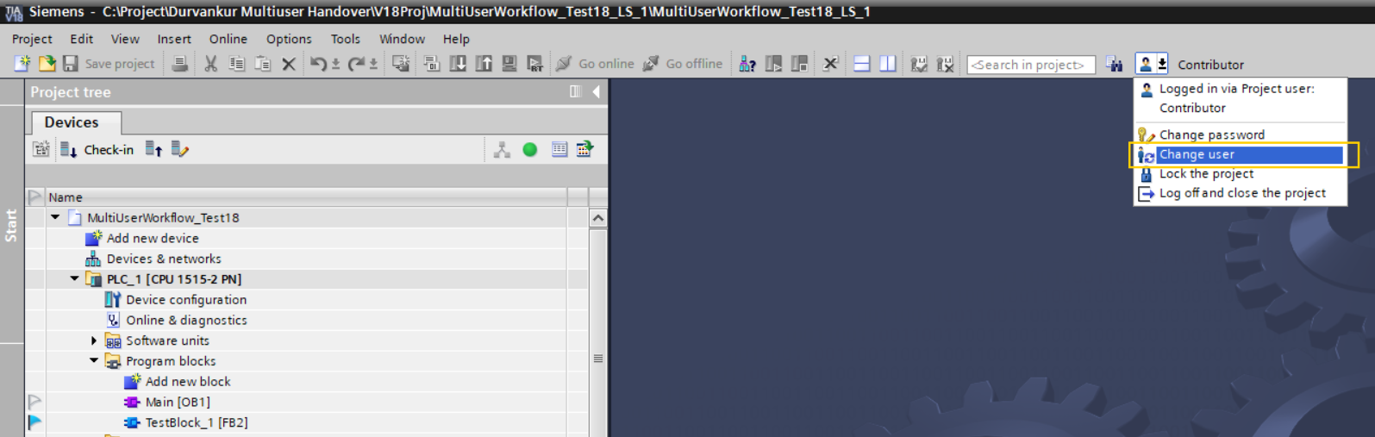
Add the “User name”, “Password” and then click on “Ok”.
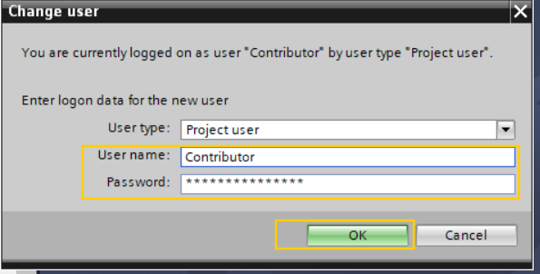

If the server is disconnected then it automatically ditect, remove the rights and show the message “Server is disconnected” (User need to relogin).
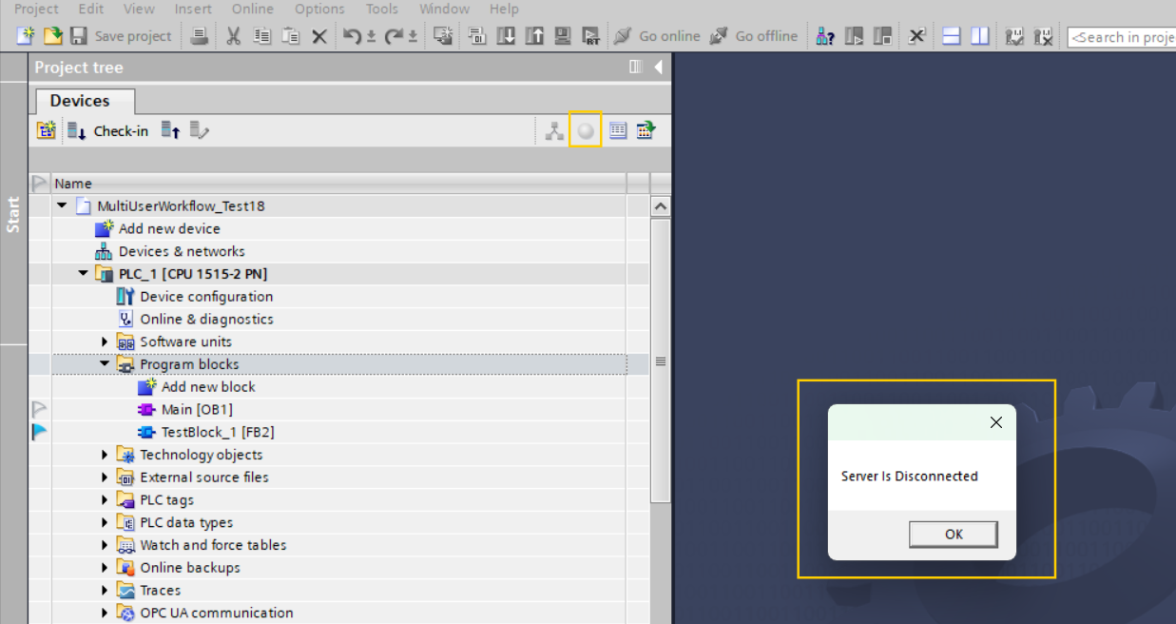

For relogin follow the below steps :
Select the “Change user” from the user section.
Add the “User name”, “Password” and then click on “Ok”.

If reconnected to the server, it detects the connection, applies the rights, and displays the message: “Server Connected, Download Rights Provided, Please Relogin.”
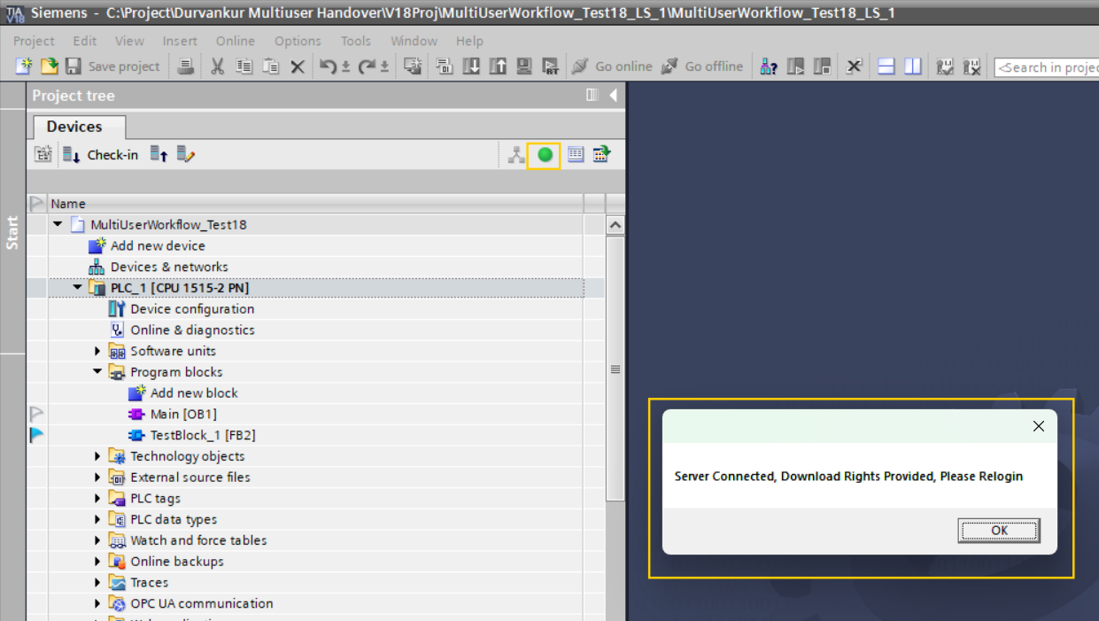
- Download Disable.
Right click on the Program blocks click on Download Enable And Disable> Download Disable.

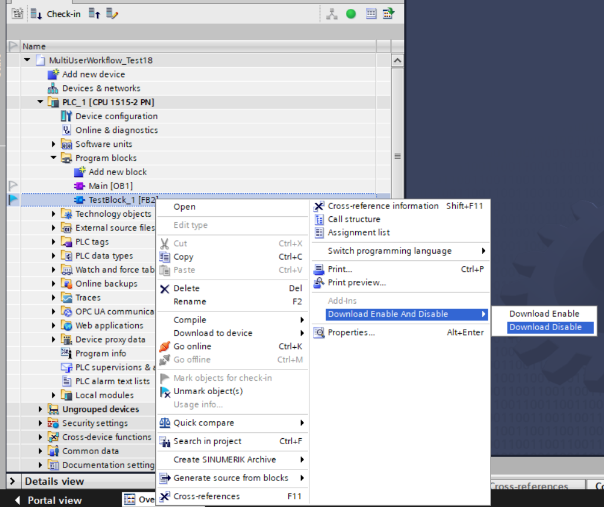
Select the server from the drop-down menu.
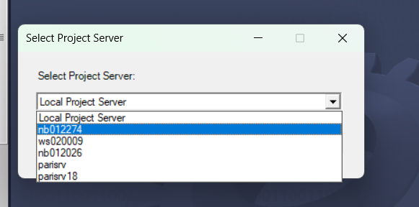
Below pop up is displayed.
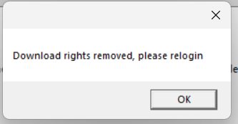
After user relogin, download rights are removed and the below pop up is displayed when user tries to download.
For relogin follow the below steps :
Select the “Change user” from the user section.
Add the “User name”, “Password” and then click on “Ok”.

